**Assignment 1**

**Module -1: Understanding of Hardware and Its Components**

Section 1: Multiple Choice

1. Which of the following is NOT a component of the CPU?

**Ans. RAM (Random Access Memory)**

1. What is the function of RAM in a computer?

**Ans. RAM Stores the data temporarily. When computer is shut down the data will automatically be erased.**

3. Which of the following is a primary storage device?

1. HDD 2. SSD 3. SD card 4. 1 and 2 both **Ans. 1 and 2 both**

4. What is the purpose of a GPU?

**Ans. GPU is specifically designed to handle and accelerate graphics workloads and display graphics content on a device such as PC or Smartphone.**

Section 2: True or False

1. The motherboard is the main circuit board of a computer where other components are attached.

**Ans. True**

1. A UPS (Uninterruptible Power Supply) is a hardware device that provides emergency power to a load when the input power source fails.

**Ans. True**

1. An expansion card is a circuit board that enhances the functionality of a component.

**Ans. True**

Section 3: Short Answer

1. **Explain the difference between HDD and SSD.**

**Ans.**

|  |  |  |
| --- | --- | --- |
| **Points** | **HDD** | **SSD** |
| Storage | Uses spinning disk to read and write the data | Uses Flash memory cells without moving parts |
| File Transfer Speed | Slower than SSD with data transfer rate 30 to 150MB/s | Faster than HDD with data transfer rate 500 to 3500MB/s |
| Storage capacity | Large storage space as compared to SSD | smaller storage capacity, but up to 8TB available. |
| Affordability | More affordable with large storage capability. | Expensive as compared to HDD. |
| Durability | Less durable, chances to loss the data due to physical damage. | Durable as it has no moving parts. |
| Energy-efficient | Consume more power and heat. | Consume less power and has cooling operations. |
| Boot time/ Application load time | Takes up to 30-40 seconds to boot. | Takes up to 10-15 seconds to boot. |

1. **Describe the function of BIOS in a computer system.**

**Ans.** BIOS is mainly responsible for starting the computer.

* It also checks and initialize the system hardware components and peripherals during the booting process.
* Its primary function is to ensure the computer can properly boot and interact with its devices.
* It performs POST (Power-On-Self-Test) during startup.

1. **List and briefly explain three input devices commonly used with computers.**

**Ans.** The most common input devices which are used with computer is below:

* Keyboard
* Mouse
* Camera
* Microphone
* Scanner
* Optical Character Reader (OCR)
* Bar Code Reader
* Optical Mark Reader (OMR)
* **KEYBOARD:**

Keyboard is the most common devices which is used to input the data into the computer. With the help of keyboard keys, one can enter the command, numbers or text in computer.

Keyboard keys are categorized in to the groups like Alphanumeric keys (A-Z), (0-9),Function Keys (F1 -F12), Control keys (Ctr, Shift, Alt, Windows), Special keys (Enter, Shift, Caps Lock, Delete, Escape, Num Lock, Space bar, Tab, and Print Screen) and navigation keys (arrow keys, Page Up, Page Down, Home, and End).

* **MOUSE:**

Mouse is a hand-held pointing device that is displayed on the monitor looks like in an arrow shape. Common feature of mouse is having two keys and one scroll wheel, used to select command and control over information.

Common types include wired (Connects via USB), wireless (use radio waves to communicate), optical (use LED and an optical sensor), laser (Use a laser beam), trackball, gaming, and Mechanical mice (Use a physical ball at the bottom).

* **SCANNER:**

Scanner allows user to add the information which is in the form of hard copy and want to store it to the hard disc in the form of scanned image.

Scanner captures the image from the source and converted it to the computer understandable format and stored it in to the computer’s memory.

Section 4: Practical Application

1. **Identify and label the following components on a diagram of a**

**motherboard:**

* **CPU**
* **RAM slots**
* **SATA connectors**
* **PCI-E slot**

**Ans.**

**SATA connectors**

**CPU**

**RAM slots**

**PCI-E slot**

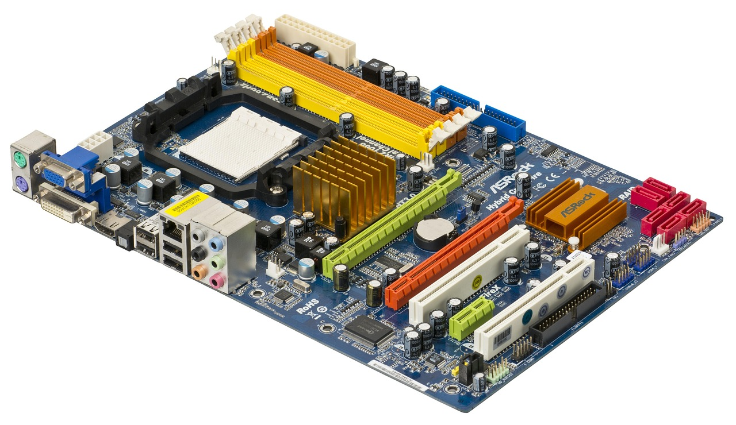

1. **Demonstrate how to install a RAM module into a computer.**

**Ans.** There are few steps to consider when you install a RAM into a computer.

1. Locate RAM slots on the motherboard

**RAM slot**

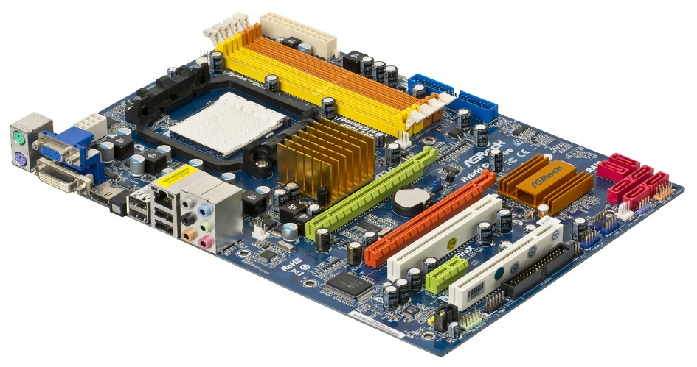

1. Open the both clips at ends of the RAM slot.

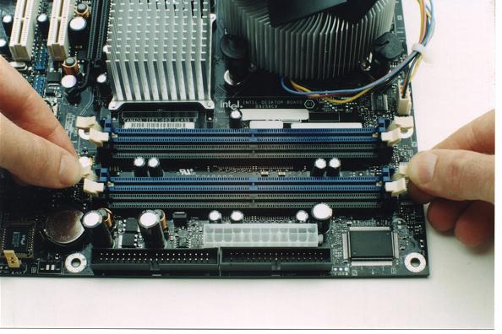

1. Align the notch on the RAM with the notch on the slot.

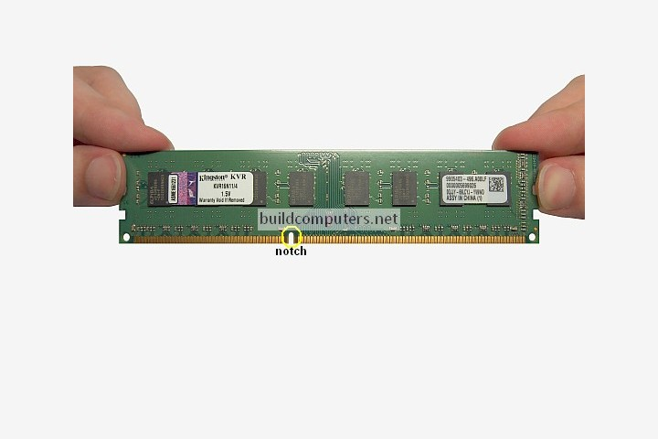

1. Insert the RAM in to the slot at 90degree angle.

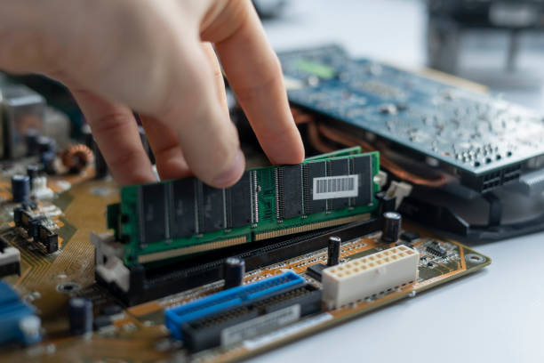

1. Apply gentle pressure until you hear a clicking sound.

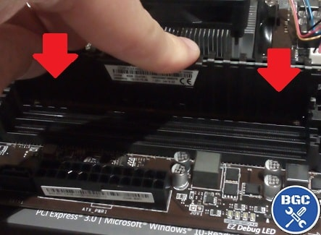

1. Verify the clips automatically close to secure the module.

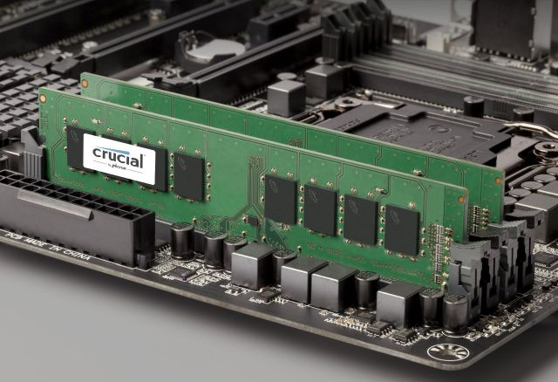

1. Power on your computer and verify that the RAM is recognized.

Section 5: Essay

1. Discuss the importance of proper cooling mechanisms in a computer system. Include examples of cooling methods and their effectiveness.

**Ans. Importance of proper cooling mechanism:**

**1.** **Performance Maintenance**  
High temperatures can cause components like the CPU and GPU to undergo thermal throttling, a process where the system automatically reduces performance to prevent overheating. This results in slower processing speeds and diminished efficiency, particularly during high-load tasks such as gaming, video rendering, or running simulations.

**2.** **Hardware Longevity**  
Over time, excessive heat can degrade electronic components, reducing their operational lifespan. Consistent and effective cooling helps maintain component integrity, extending the life of the system and avoiding costly repairs or replacements.

**3.** **System Stability and Reliability**  
Overheating can lead to frequent crashes, data corruption, or complete system shutdowns. Proper cooling ensures that the system remains stable and reliable, especially during intensive computing operations.

**4. Energy Efficiency**A well-cooled system operates more efficiently. Components running at lower temperatures require less energy for heat dissipation, leading to reduced overall power consumption and operating costs.

**Examples of Cooling Methods and their effectiveness:**

1. **Air Cooling:**

This is the most common and affordable method, using fans to move air over heat sinks to dissipate heat. Fans can be passive (no fan) or active (with a fan). Example is Stock or aftermarket CPU coolers like the Cooler Master Hyper 212.

**Effectiveness:** Effective for moderate performance needs and cost-effective, but Less effective in high-performance systems or in poorly ventilated cases.

1. **Liquid Cooling:**

Liquid cooling uses a liquid coolant (often water or a mixture of water and glycol) to transfer heat away from the CPU or GPU, and then a radiator with fans cools the liquid. Example is AIO (All-in-One) coolers like the NZXT Kraken series or custom loops.

**Effectiveness:** Offers superior cooling performance, ideal for overclocked or high-performance systems, and can be quieter than air cooling, but is more expensive and complex to .

1. **Passive Cooling:**

Passive cooling relies on heat sinks and fins to dissipate heat through conduction and radiation, without fans. Example is Raspberry Pi heat sinks, fanless laptops.

**Effectiveness:** Suitable for low-power systems or situations where noise is a concern, but less effective for high-performance components.

1. Explain the concept of bus width and its significance in computer architecture.

**Ans. Bus Width and Its Significance in Computer Architecture:**

In the field of computer architecture, the term bus refers to a system of pathways or channels that allows different components of a computer to communicate with each other. These buses are essentially a collection of wires that carry data, addresses, and control signals. One of the key characteristics of a bus is its width, commonly known as the bus width, which determines how much data can be transferred across the bus at one time.

Bus width is measured in bits, and it represents the number of bits that can be sent or received simultaneously. For example, a 32-bit bus can transmit 32 bits of data in one operation, whereas a 64-bit bus can transmit 64 bits at a time. This width is a crucial factor in determining the overall performance and speed of a computer system, as it directly affects the amount of data that can be moved in a given time period.

There are three main types of buses in a typical computer system:

1. **Data Bus**: This is the most directly affected by bus width. It carries the actual data that is being processed. The wider the data bus, the more data the CPU can handle at once, which can significantly improve processing speed.
2. **Address Bus:** This carries information about where the data should be read from or written to in the memory. A wider address bus allows the system to access a larger memory space. For example, a 32-bit address bus can address up to 4 gigabytes (2³²) of memory, while a 64-bit address bus can theoretically access up to 18 exabytes (2⁶⁴).
3. **Control Bus:** This carries control signals that manage and coordinate the activities of the processor and other components, such as signals indicating whether data is being read or written.

The bus width is significant for several reasons:

* **Performance:** A wider bus allows more data to be transferred per clock cycle, increasing the throughput of the system. This is especially important for data-intensive applications such as video editing, gaming, scientific simulations, and large database management.
* **System Capability:** As software becomes more advanced, the need for handling larger volumes of data also increases. Wider buses support these demands by ensuring that the hardware can efficiently move data to and from the processor.
* **Memory Access:** A wider address bus allows the system to support more memory. This is one reason why modern 64-bit systems can use much more RAM than older 32-bit systems. In today’s computing world, where multitasking and large applications are common, access to more memory is essential.
* **Compatibility and Design:** Bus width also influences hardware design and compatibility. For example, a CPU with a 64-bit data bus will require memory modules and motherboard architecture that support 64-bit transfers to utilize its full potential.